Francis Driscoll 05/02/2023

Using Data Science to Aid in Smuggling Interdiction

Hook

As of 2023, second to Russia, Iran is the most sanctioned country in the world largely due to efforts to dissuade the Iranian government from pursuing the development of nuclear weapons. Iran holds 10% of the worlds oil reserves, and Iran’s economy is extremely dependent on revenues from the exports of oil. In response to sanctions that prohibit oil exports, the Iranian government has become involved with huge oil smuggling programs which decrease the effectiveness of US sanctions. As of March 2023, Iranian oil exports have hit their highest level since the imposition of US sanctions in 2018, and most of these exports can be attributed to illegal smuggling by ships in the Persian Gulf. The US treasury department is seeking a brilliant data scientist to develop efficient methods to estimate the amount of oil smuggling occurring from ports in Iran in order to ensure that sanctions aimed at preventing the rise of Iran’s nuclear program are effective.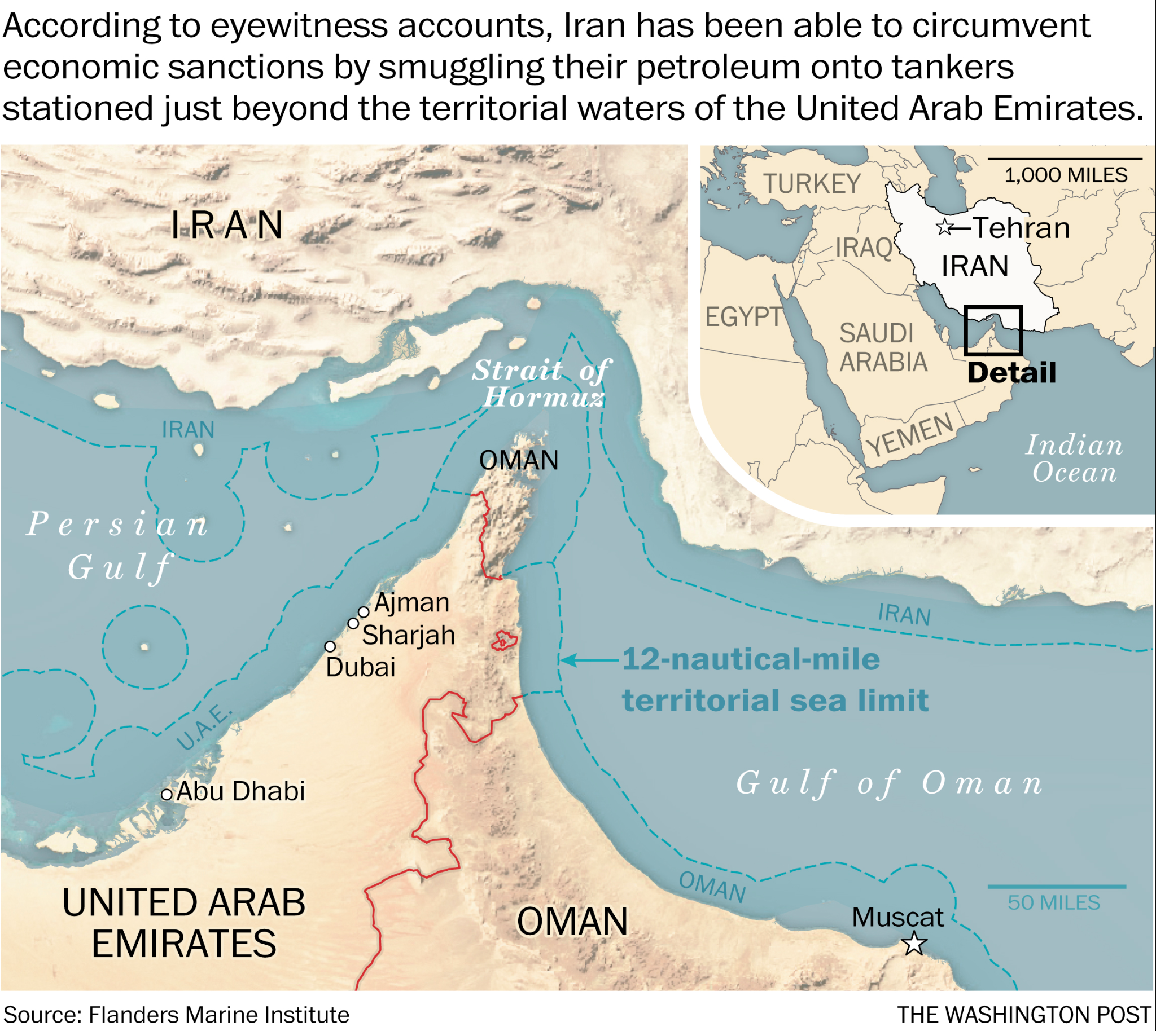

Prompt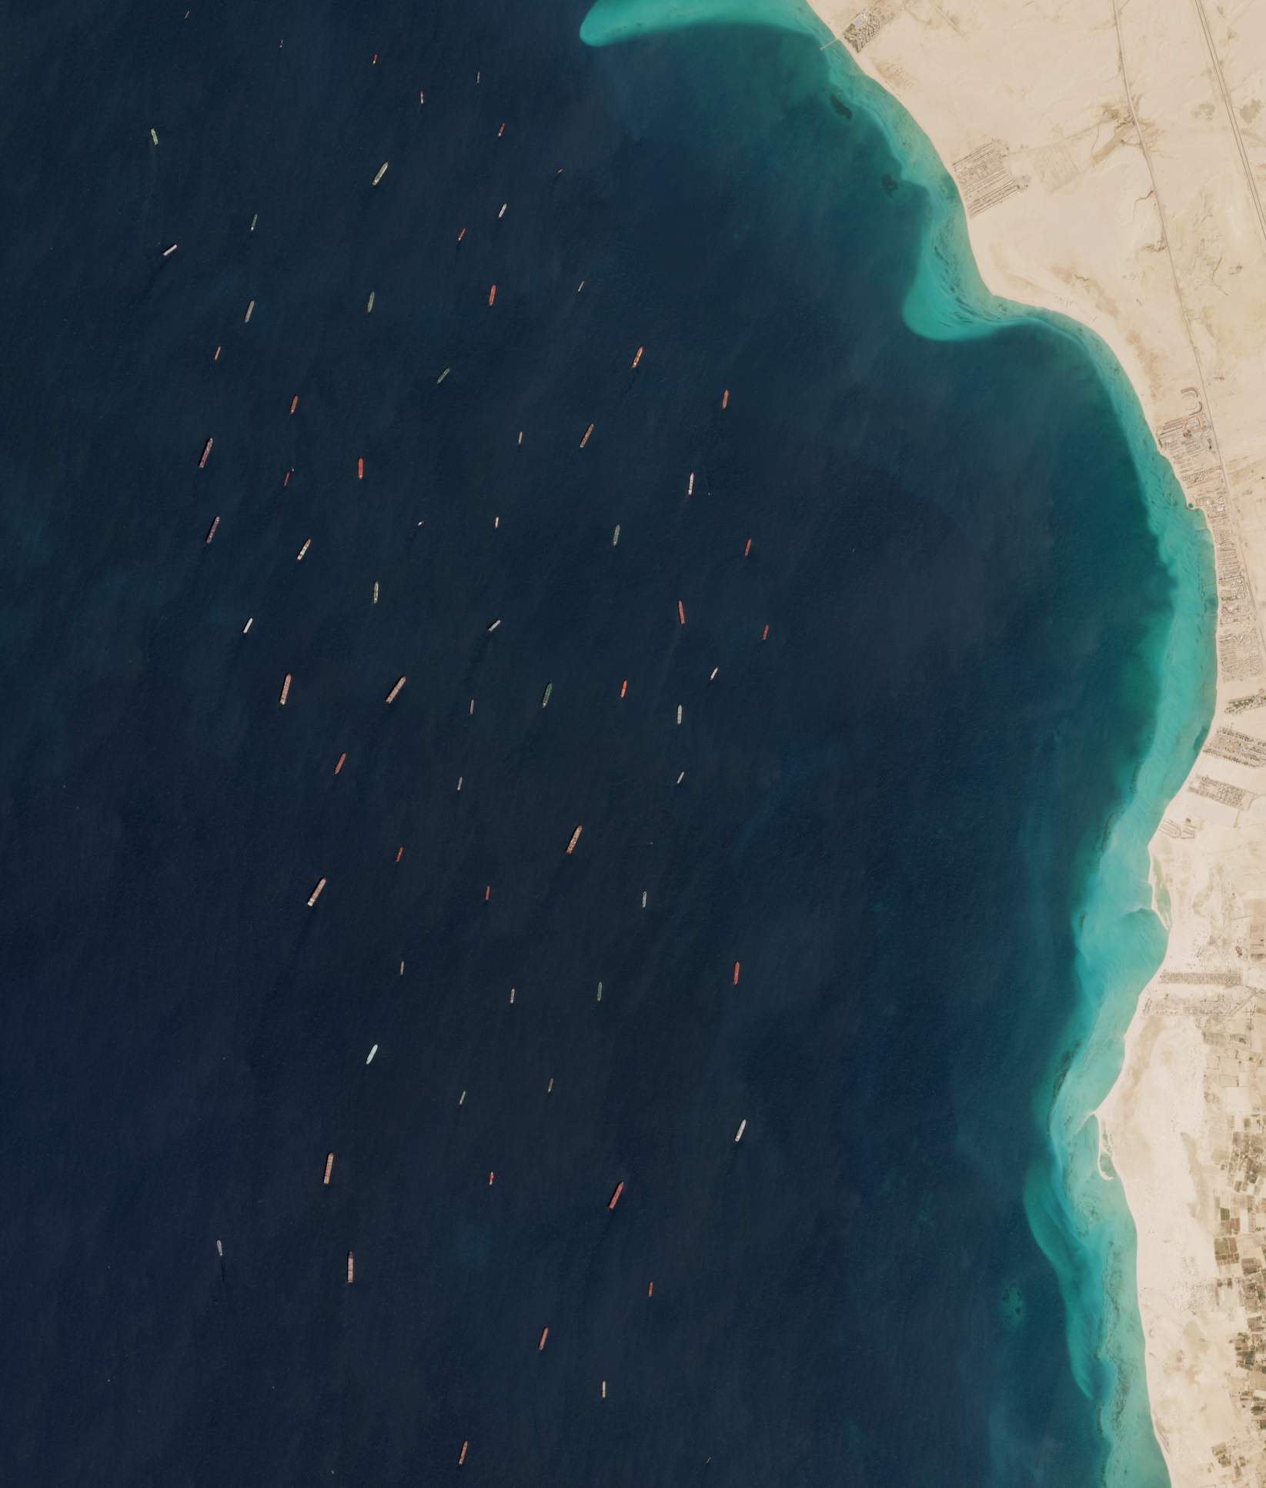

Since the US and other nations first imposed sanctions on Iran following the seizure of the American embassy in 1979, the Iranian government has implemented methods to evade sanctions and bring Iranian goods to international markets illicitly. Iranian oil tankers may change their names as they leave Iranian ports, they may transfer their oil cargoes onto other ships once at sea, or the oil tankers may turn off their Automatic Identification System (AIS) transponders which allow them to disappear from tracking systems that ships use to determine the position of other ships. As the Persian Gulf is crowded with 20% of the world’s oil trade, it is easier for ships carry iranian oil to evade authorities deployed to the Gulf to interdict smuggling. Thus, the US government is searching for a way to use satellite imagery and AIS tracking data to develop a framework for identifying ships that are likely to be smuggling.

Deliverable

The US treasury department is seeking a deliverable that includes the full scope of data science programs required to identify ships suspected of smuggling. The task is to develop a computer vision model that can identify ships from a satellite image. Once you have developed a model that can automatically identify ships, you will then use provided, hypothetical AIS data about those ships to identify suspects of smuggling. Using actual real-time satellite imagery and position data from AIS tracking websites like VesselFinder.com with the system you develop could be used in the real world to identify ships that are suspicious of illegal oil smuggling activity.

**Helpful Reference Materials**

Resources to understand the context of the problem

* Middle East Institution Iranian sanction evasion

<https://www.mei.edu/publications/iranian-sanctions-evasion-and-gulfs-complex-oil-trade>

* Satellites, Big Data help US spy on Smugglers of Iranian oil

<https://www.wsj.com/articles/as-new-iran-sanctions-loom-oil-smuggling-is-a-tougher-racket-1541076444>

Resources to understand the development of a computer vision model

* Deep Learning for Ship Detection and Segmentation: An end to end pipeline for deep learning on satellite imagery - Abhinav Sagar

<https://towardsdatascience.com/deep-learning-for-ship-detection-and-segmentation-71d223aca649>

* Airbus Ship Detection Challenge on Kaggle

<https://www.kaggle.com/c/airbus-ship-detection/overview>

Resources to test your model and ability to amalgamate satellite imagery work with AIS position data

* Satellite image to run your trained computer vision model on



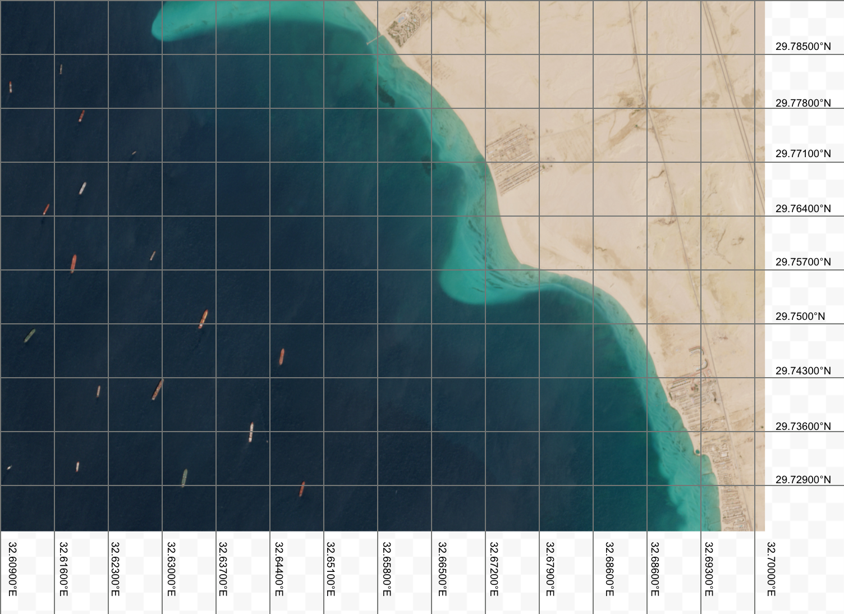

* For the purposes of this case study, these are the coordinates of the ships in the area shown in this satellite image pulled from vesseltracker.com. Vesseltracker.com records the position of ships via their AIS transponders. This position data was recorded at the same time that the satellite image was taken.

| **Latitude** | **Longitude** |
| --- | --- |
| 29.781°N | 32.611°E |
| 29.783°N | 32.617°E |
| 29.777°N | 32.619°E |
| 29.772°N | 32.626°E |
| 29.765°N | 32.615°E |
| 29.768°N | 32.620°E |
| 29.759°N | 32.628°E |
| 29.749°N | 32.612°E |
| 29.746°N | 32.646°E |
| 29.741°N | 32.622°E |
| 29.732°N | 32.611°E |
| 29.732°N | 32.619°E |
| 29.731°N | 32.633°E |
| 29.729°N | 32.648°E |

**Rubric**

**Task:** In this project, you are tasked with developing a computer vision modelt to identify ships from satellite imagery and using this model in conjunction with AIS ship tracking data to identify ships that are suspected of smuggling.

**How will I know I have succeeded?** You will meet expectations on CS2 Create Case Study when you follow the criteria in the rubric below.

| Spec Category | Spec Details |
| --- | --- |
| Formatting | Under this assignment, submit all sections described in this rubric. Submit each as separate files. Written portion, code file, and the visualization. |
| Written Portion | Submit as a Word doc on collab  The doc must include:   * Brainstorm section: This case study involves some abstract problem solving. In order to help you think through the problem before jumping into coding or mapping work, write out a paragraph about how you are thinking about the problem. This should read very casually and could be written in a stream of consciousness kind of format. Include bullets of ideas explored even if you later decide against approaching the problem in that way. The purpose of this section is for you to be intentional about brainstorming different approaches, and for the grader to assess your ideas. * A two paragraph section in which you reflect on your process and findings and describe in detail:   + Your method for solving this problem: How did you build your computer vision model? How did you extract and bring the satellite images into your workflow? How are you assessing your model’s accuracy? How are you bringing the model into the specific context of the problem and making it applicable?   + Your conclusions: How successfully did your model identify ships? What strengths does your solution have? What potential weaknesses do you foresee being a challenge with applying your deliverable? |
| Code File | Attach your file which includes all of the code you used for this project. The code should be thoroughly commented so a viewer with little context would be able to understand your process |
| Visualization | Attach the satellite image provided after the computer vision model has highlighted each of the ships its detected. Using the location information provided, circle which of the ships you suspect of smuggling. |